

GROUP ASSIGNMENT

**(CT-077-3-2-DSTR)**

**DATA STRUCTURES**

**PURCHASE ORDER MANAGEMENT SYSTEM DOCUMENTATION**

**APD2F2111CS(CYB)**

**GROUP MEMBERS: HESKEY HEW U CERN (TP058243)**

**LEE JUN LAM (TP055697)**

**Propose Title: Purchase Order (PO) Management System**

**HAND OUT DATE: 10th June 2022**

**HAND IN DATE: 30th July 2022**

**WEIGHTAGE: 5%**

INSTRUCTIONS TO CANDIDATES:

1. **Submit your assignment through Moodle (Online Submission).**
2. **Read and follow the instructions carefully.**
3. **Late submission will be awarded zero (0) unless Extenuating Circumstances (EC) are upheld.**
4. **Cases of plagiarism will be penalized.**

**You must obtain 50% overall to pass this module.**

**Table of Contents**

Introduction 3

Data Structures and Classes Created 4

Brief Explain About the Algorithms 12

Screenshots of Input and Output Samples 30

Conclusion 38

References 39

Workload Matrix 40

Source Code of Main Function 41

# Introduction

It is essential that every organization owns a purchase order management system. These systems are internal purchasing mechanisms that are typically used by businesses to optimize its purchases. As people move toward a more technologically oriented future, the conventional way of storing records through the use of pen and paper is not regarded as a reliable and efficient method anymore. LiveOrder Sdn. Bhd. has approached to seek help in developing a purchase order management system for their established online store that offers various goods. The proposed purchase order management system will be divided into two main user accesses/roles, in which, are Sales Order Executives and Administrators. The Sales Order Executive role consists of several capabilities and features, including acquiring online records of purchase orders, editing, and modifying orders in accordance with LiveOrder’s preferences, displaying all purchase orders available, searching and sorting purchase orders in reference to the user’s priorities, and the ability to log in and out of the system. On the other hand, the administrator role also contains many functions that users can access. This role will consist of all the functionalities that the Sales Order Executive role will have, and additionally, will have the ability to generate reports such as sales reports, and sorting these reports based on the provided criteria by the user. Through the development and creation of this purchase order management system for LiveOrder Sdn. Bhd., the business will be able to operate in a more compliant and effective manner, as this system can minimize the risk of human-errors and the total time consumption used when accessing records.

# Data Structures and Classes Created

In this project, 3 data structures with be created which are Sales, Customer, and Items. Each sales record should be provided together with the rest of the data structures.

Linked List

An informational list with links is referred to as a linked list. It is linked to another in each connection and to keep data pieces in a linear yet dispersed among numerous approaches. This data structure is the one that is utilized the most in this project. When a system is developed using linked lists, users may show data in an organized way and it cannot be accessed arbitrarily as it is a dynamic, adaptable linear data structure and its size might change depending on the situation thus reducing memory wastage. Each node in a linked list has a reference to the node after it, rather than storing the data in memory locations. The last item in the list has its next pointer set to null, signaling the end of the list (Software Testing Help, 2022). Meanwhile, the first item on the list is referred to as The Head. The linked list supports several operations, such as insertion, deletion, traversal, etc. These data pieces are represented by nodes, and each node is connected by links or pointers that contains the address of the node after it make up each node's two fields (tutorialspoint, n.d.).

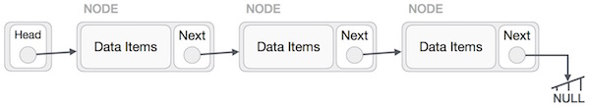

*Figure: Example of Linked List*

Classes Created

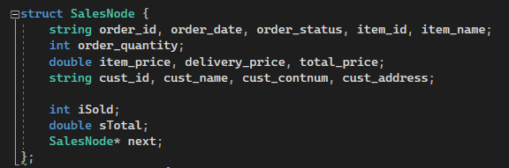

The first class created is “SalesNode”. It stores the details of each order into the system. The table below indicates the purpose of each data member created within the class.

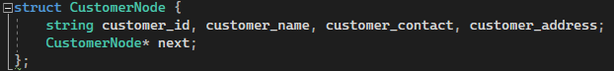

The second class created is “CustomerNode”. It stores details of the customers that will be stored in the system.

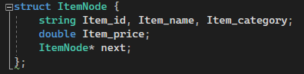

The third and final class created is “ItemNode”. This will store the details of each item into the system.

|  |  |
| --- | --- |
| **Name** | **Purpose** |
| order_id (string) | Stores Order ID for each order in “SalesNode”. |
| order_date (string) | Stores the Order Date for each order in “SalesNode”. |
| order_status (string) | Stores the Order Status for each order in “SalesNode”. |
| item_id (string) | Stores the Item ID for each item in “SalesNode”. |
| item_name (string) | Stores the Item Name for each item in “SalesNode”. |
| order_quantity (integer) | Stores the Order Quantity for each item in “SalesNode”. |
| item_price (double) | Stores the Item Price for each item in “SalesNode”. |
| delivery_price (double) | Stores the Delivery Price for each order in “SalesNode”. |
| total_price (double) | Stores the Total Price for each order in “SalesNode”. |
| cust_id (string) | Stores the Customer ID for each customer in “SalesNode”. |
| cust_name (string) | Stores the Customer Name for each customer in “SalesNode”. |
| cust_contnum (string) | Stores the Customer Contact Number for each customer in “SalesNode”. |
| cust_address (string) | Stores the Customer Address for each customer in “SalesNode”. |
| iSold (integer) | Stores the Total Items Sold in “SalesNode”. |
| sTotal (double) | Stores the Sales Total in “SalesNode”. |

|  |  |
| --- | --- |
| customer_id | Stores the Customer ID for each customer in “CustomerNode”. |
| customer_name | Stores the Customer Name for each customer in “CustomerNode”. |
| customer_contact | Stores the Customer Contact Number for each customer in “CustomerNode”. |
| customer_address | Stores the Customer Address for each customer in “CustomerNode”. |
| Item_id | Stores the Item ID for each item in “ItemNode”. |
| Item_name | Stores the Item Name for each item in “ItemNode”. |
| Item_category | Stores the Item Category for each item in “ItemNode”. |
| Item_price | Stores the Item Price for each item in “ItemNode”. |

Method Headers

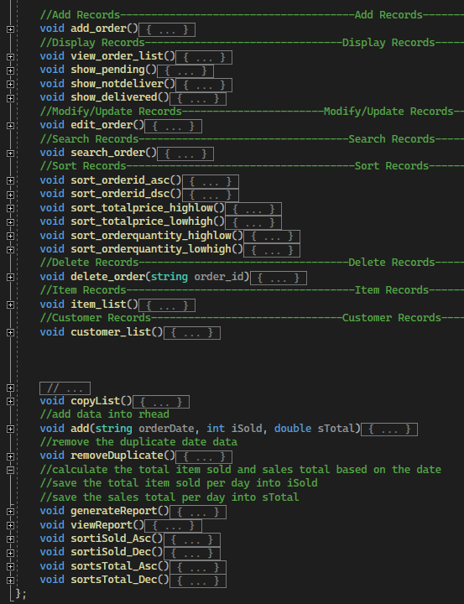

|  |  |
| --- | --- |
| **Method Header** | **Purpose** |
| add_order | Allows user to add new orders to the system. |
| view_order_list | Allows user to view all existing orders. |
| show_pending | Allows user to view all “Pending” orders. |
| show_notdeliver | Allows user to view all “Not Deliver” orders. |
| show_deliver | Allows user to view all “Delivered” orders. |
| edit_order | Allows user to edit order details, for example Customer ID, Customer Address, etc. |
| search_order | Allows user to search orders based on criteria such as Order ID, Item ID, etc. |
| sort_orderid_asc | Allows user to sort order records based on ascending order of Order ID. |
| sort_orderid_des | Allows user to sort order records based on descending order of Order ID. |
| sort_totalprice_highlow | Allows user to sort order records based on highest to lowest total price. |
| sort_totalprice_lowhigh | Allows user to sort order records based on lowest to highest total price. |
| sort_orderquantity_highlow | Allows user to sort order records based on highest to lowest order quantity. |
| sort_orderquantity_lowhigh | Allows user to sort order records based on lowest to highest order quantity. |
| delete_order | Allows user to delete order records from list. |
| item_list | Allows user to view item detail such as item category, item price, etc. |
| customer_list | Allows user to view customer detail such as Customer ID, Customer Name, etc. |
| copyList | Duplicates the list of data to avoid changes in the main list. |
| removeDuplicate | Removes the duplicated date data. |
| generateReport | Allows user to generate report based on total items sold, sales total on a specific date. |
| viewReport | Allows user to view report, but only when a report has already been generated. |
| sortiSold_Asc | Allows user to sort report based on ascending order of items sold. |
| sortiSold_Des | Allows user to sort report based on descending order of items sold. |
| sortsTotal_Asc | Allows user to sort report based on ascending order of sales total. |
| sortstotal_Des | Allows user to sort report based on descending order of sales total. |

Justification

Several linked list techniques were used into this application to control the data structure of the PO management system: First of all, a **sorting** algorithm is used to reshuffle the components in a list of items after a comparison operator has been applied. Using the comparison operator, the elements in the appropriate data structure are positioned in a new arrangement. It is recommended employing the **insertion sort** technique in sorting algorithms as the insertion sort method is an easy process that efficiently handles small data values in a single linked list. It separates the list into pieces that are sorted and unsorted (GeeksForGeeks, 2022). At the start of iteration, unsorted elements are inserted into ascending order using the insertion sort method. The following iteration's locations are switched if the combined pair of the current unsorted elements is more than the next element and does nothing if the unsorted element is smaller than the next element for this combined pair (Programiz, n.d.). It is possible to keep the sorted portion orderly because it is initially empty by having components go from the unsorted part to the sorted part one at a time. The committee recommended that the system have at least 10 records of data. Due to the system's limited data, the insertion algorithm may be applied.

Next, **searching** algorithms are employed in the creation of purchase order systems in an effort to locate an entity or obtain it from any data structure in which it is stored (GeeksForGeeks, 2022). In this project, one out of two different search operations will be used: **Search in sequence**: This approach examines each list or array element as it is visited consecutively. The researchers consequently proposed employing linear search to extract system components. The simple linear search technique begins by running over each element of the array one by one till the end of the list. If the user key matches the element, the element will be added back to the list along with the value true. If the user keyword matches the element, the element will be returned back to the list along with the value true. If none of the items match the element, it will return false. To discover the match element, the while loop function is applied to verify each item to see if it matches. If it does, the element is returned, and the search is over; otherwise, it keeps searching until the end of the data list. If the element cannot be located, no data will be returned. It works well for smaller, unsorted arrays with fewer elements in data lists. This system uses linear search to update and look up sales reports and sales data.

In addition, **delete** algorithms are employed in the creation of purchase order systems in an effort to remove any data which is stored after the entity has been located. To delete data, there are 3 ways (delete from beginning, delete from middle and delete from end). In this case, only **delete from beginning** is applied as the simplest operation is removing a node from the list's beginning. Just a few changes to the node pointers are required as the system just needs to make the head of the list point to the next head since the first node of the list has to be erased (javaTpoint, n.d.). However, if the node that deleted is not from the beginning, loop function should be apply in search algorithm in order to discover the match element to delete the particular node.

# Brief Explain About the Algorithms

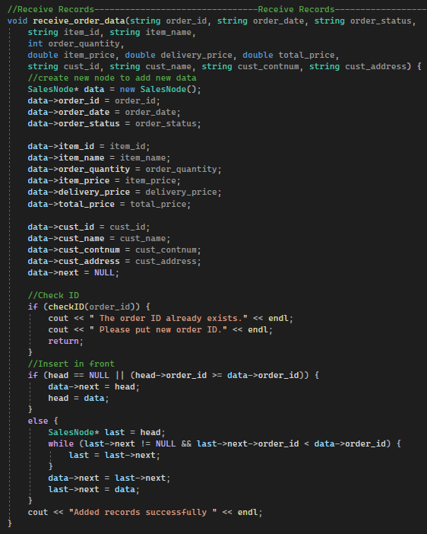Receive Records

This function will create new records when it is called. A node will first be created under the name “SalesNode()”, and the system will check for duplicating orders with the same Order ID before the application is running. The user will need to input an Order ID to create a new record, and it will only be created if Order ID is unique from existing Order IDs. System will then assign values to the attributes (order_id, order_date, order_status, item_id, item_name, order_quantity, item_price, delivery_price, total_price, cust_id, cust_name, cust_contnum, and cust_address) using the variable “data”. If the “SalesNode()” is empty, the system will input the record at the top of the list, whereas if there are already existing data, the record will be placed at the bottom of the list. User will be prompted that the records have been added as the system will display “Added records successfully”.

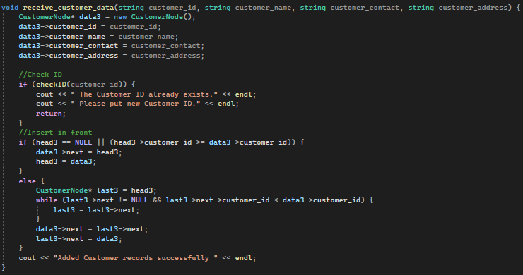Receive Customer Data

This function will create new Customer records when it is called. A node will first be created under the name “CustomerNode()”, and the system will check for duplicating orders with the same Customer ID before the application is running. The user will need to input a Customer ID to create a new record, and it will only be created if Customer ID is unique from existing Customer IDs. System will then assign values to the attributes (cust_id, cust_name, cust_contnum, and cust_address) using the variable “data”. If the “CustomerNode()” is empty, the system will input the record at the top of the list, whereas if there are already existing data, the record will be placed at the bottom of the list. User will be prompted that the records have been added as the system will display “Added records successfully”.

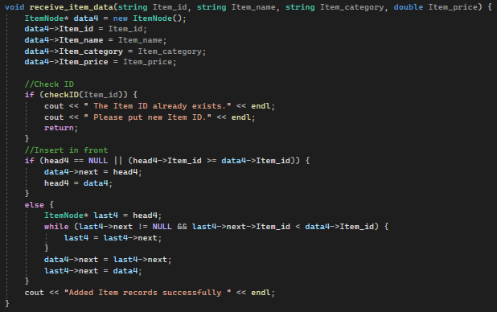Receive Item Data

This function will create new item records when it is called. A node will first be created under the name “ItemNode()”, and the system will check for duplicating orders with the same Item ID before the application is running. The user will need to input an Item ID to create a new record, and it will only be created if Item ID is unique from existing Item IDs. System will then assign values to the attributes (Item_id, Item_name, Item_category, and Item_price) using the variable “data”. If the “ItemNode()” is empty, the system will input the record at the top of the list, whereas if there are already existing data, the record will be placed at the bottom of the list. User will be prompted that the records have been added as the system will display “Added records successfully”.

Add Records

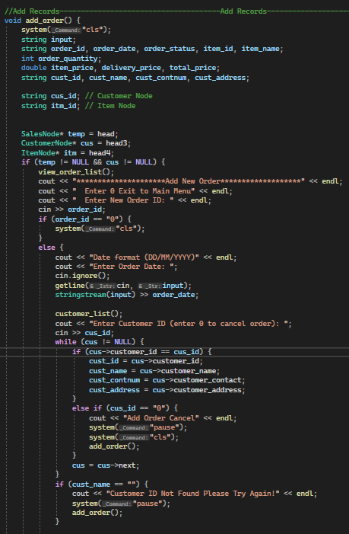

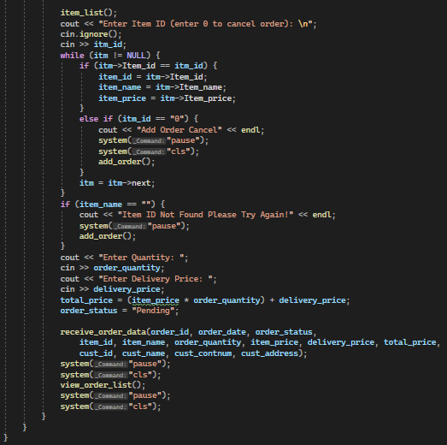

The add_order function is intended to add new record into order list. First of all, 3 pointers had been assigned to point to the top of “SalesNode”, “CustomerNode” and “ItemNode” classes respectively and each pointer has been assigned with different variable name in order to store the existing records from order list, customer list and item list into each variable respectively.

Then, user will be requested to input new order id (if an existing order id is input, the new record will not be added due to receive_order_data function has been coded with no duplicate order id accepted). Next, user is requested to input date and following by valid customer id that exist in “CustomerNode”. The while loop function is applied to read the entire customer data and to compare with the input customer id. If the customer_id is not existed, the customer data will not be added and thus an error message will be displayed to request user input valid customer id. Next, user will be requested to input valid item_id which exist in “ItemNode”. If the item_id is not existed, the item data will not be added and thus an error message will be displayed to request user input valid item id. Next, user is required to enter order quantity and delivery price (the order status with be automatic assign to “Pending”). If the add order process success, the receive order data function will implemented to display all existing records with the new added record.

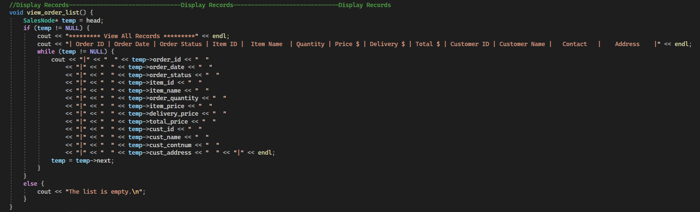Display ALL Records

This function will allow users to display all existing records. The pointer will point to the top of “SalesNode” and will store the data into a variable named “temp”. The “temp” variable will then be displayed into its respective column (e.g., Order ID, Order Status, etc). After displaying all data, the “temp” variable will proceed to the next available orders and display its elements until eventually all existing orders have been displayed.

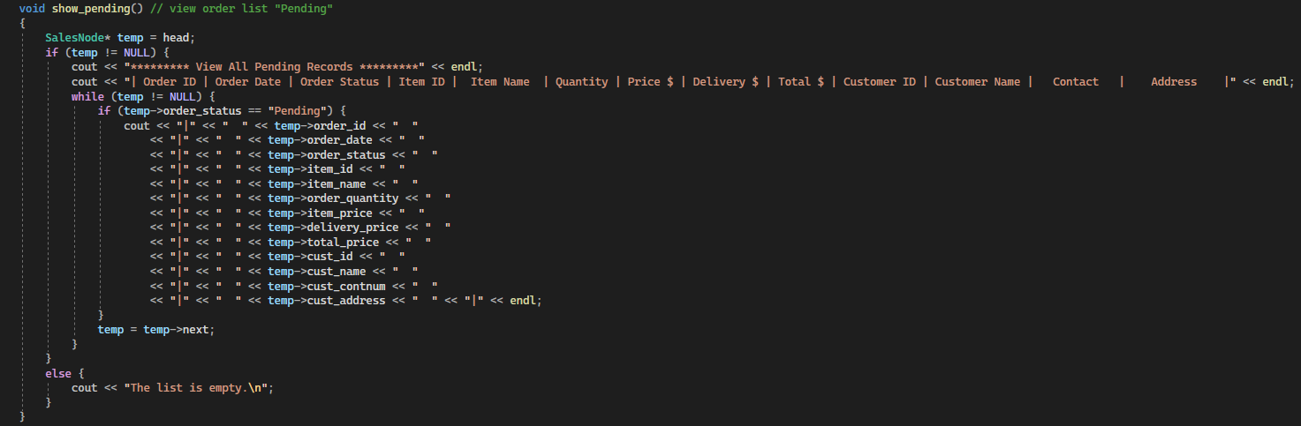Display Pending Records

Similar to the Display ALL Records function, this function will only display orders in which its Order Status is stored as “Pending”. This can be done by implementing and “if” function, where the “temp” variable will only store data if the data member “order_status” is found to be “Pending”.

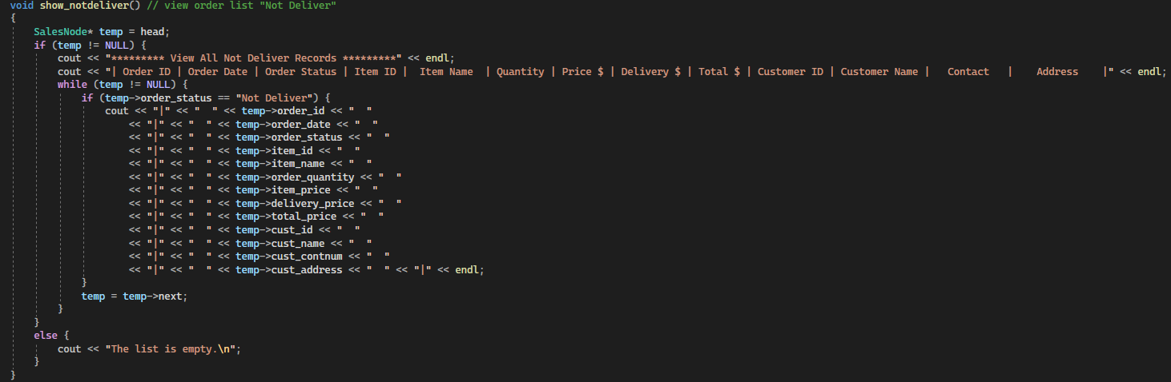Display Not Delivered Records

Similar to the Display ALL Records function, this function will only display orders in which its Order Status is stored as “Not Deliver”. This can be done by implementing and “if” function, where the “temp” variable will only store data if the data member “order_status” is found to be “Not Deliver”.

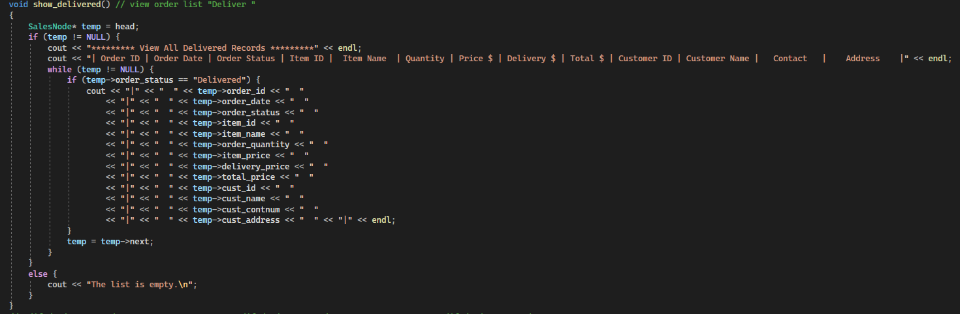Display Deilvered Records

Similar to the Display ALL Records function, this function will only display orders in which its Order Status is stored as “Delivered”. This can be done by implementing and “if” function, where the “temp” variable will only store data if the data member “order_status” is found to be “Delivered”.

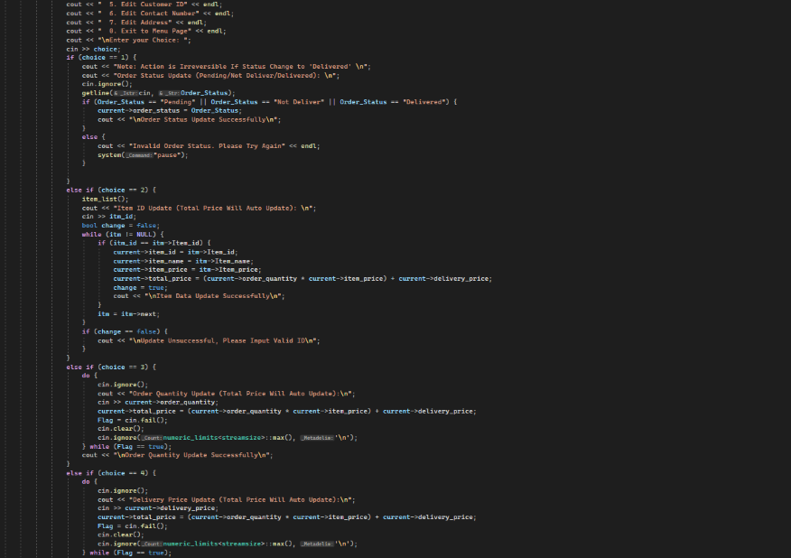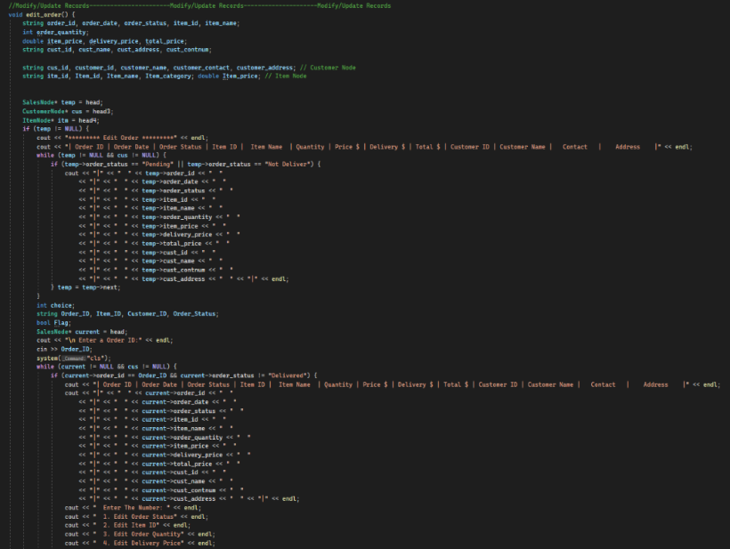Modify Records

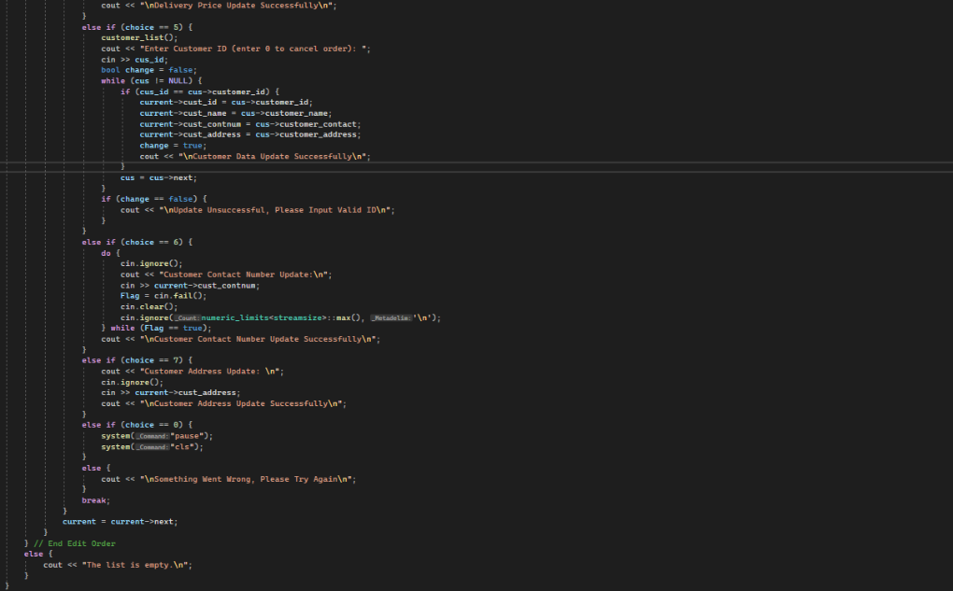

For linked list, to edit data, there are 3 ways. For instance, by updating the node’s data value,

adding the node in the list, and removing the node from the list. Using a loop, we may traverse a doubly linked list starting from the start node to the nth node. To edit a data, the input from the user will be retrieved to find any element matching the data given by the user. Once, it’s matched, the element will be replaced with the new data.

The edit_order function is intended to modify existing order list record (only records with order_status “Pending” or “Not Deliver”). First of all, 3 pointers had been assigned to point to the top of “SalesNode”, “CustomerNode” and “ItemNode” classes respectively and each pointer has been assigned with different variable name in order to store the existing records from order list, customer list and item list into each variable respectively. Then, the algorithm will first display existing order_list and user will be requested to input any existing order id to edit particular order data (if the order_id is not present in the display list, no data will be shown). Next, user given various choice to input through the IF function:

1. **Exit to Menu Page**: If the input number is 0, user will be redirect back to menu page
2. **Edit Order Status**: If the input number is 1, user can edit order status into Pending, Not Deliver or Delivered. Any invalid order status input will be denied and if the order status has been changed to Delivered, user no longer can modify the particular order data.
3. **Edit Item ID**: If the input number is 2, a list of items will be display by item_list function. user will be requested to input valid item_id which exist in “ItemNode”. If the item_id is not existed, the item data will not be added and thus an error message will be displayed to request user input valid item id. Meanwhile, if the item_id is existed in the Item list, the existing item_id, item_name, item_price will be replaced with the appropriate item data and the total price will automatically update based on the item_price, order_quantity and delivery_price.
4. **Edit Order Quantity**: If the input number is 3, user is requested to input valid order quantity. Then, the order quantity will multiply with item price and delivery price will be added to update into latest total price.
5. **Edit Delivery Price:** If the input number is 4, user is requested to input valid delivery price. Then, the order quantity will multiply with item price and updated delivery price will be added to update into latest total price.
6. **Edit Customer ID**: If the input number is 5, a list of customer details will be display by customer_list function. user will be requested to input valid customer_id which exist in “CustomerNode”. If the customer_id is not existed, the customer data will not be update and thus an error message will be displayed to request user input valid customer id. Meanwhile, if the customer_id is existed in the Customer list, the existing customer_id, customer_name, contact_number and customer_address will be replaced with the appropriate customer data.
7. **Edit Contact Number**: If the input number is 6, user will be requested to input contact number and the existing contact number will be replaced based on the particular order_id.
8. **Edit Address** If the input number is 7, user will be requested to input new address and the existing customer address will be replaced based on the particular order_id.

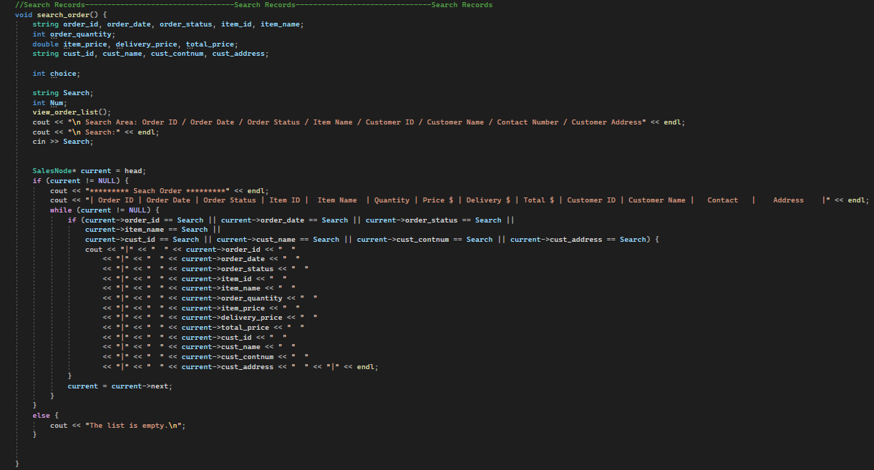Search Records

The linked list the developer going to use searching node in singly linked list. It will verify whether the particular key is present or not in the linked list. The method of locating the location of a specific element in a list. To search an element in a list, we should traverse through the list. Next, we will get the difference of each element of the list with the specific element.

The search records function behaves nearly similar to sort function. However, the difference is the order list will be filter based on user’s input keywords that matches to the order_id, order_date, order_status, item_name, customer_id, customer_name, contact_number or customer_address through the IF function. The “current” variable will then be displayed into its respective column (e.g., Order ID, Order Status, etc). By transverse through the list, the “current” variable will proceed to the next order to search for match keywords and display its elements in the particular node in the link list.

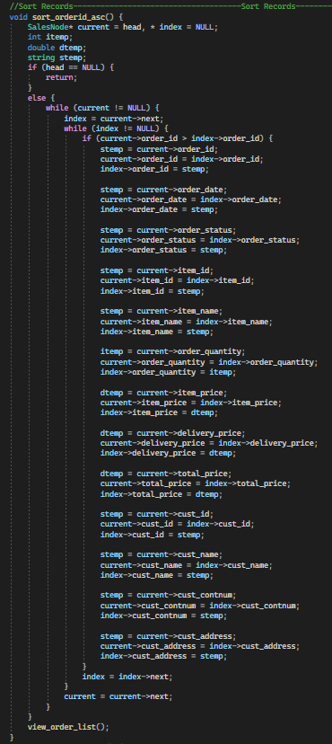Sort Records by Ascending Order ID

The first step to sorting data in ascending order is to ensure that the head is not empty (list cannot be empty). Maintain the current and index pointers if the head is not empty. Current will initially point to the head node and index will point to the node after current. By comparing the data from current and index, go through the list until current points to null. If the order id of the current data is higher than that of the index, then the data should be swapped between the two. The whole order record is then shown in ascending order using the view order list() method.

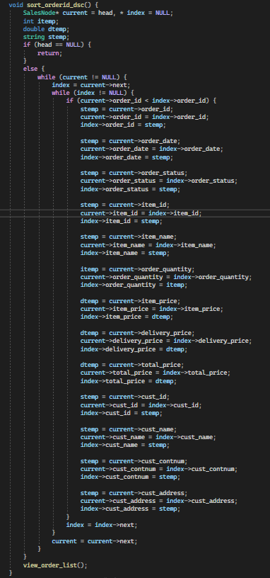Sort Records by Descending Order ID

The first step to sorting data in descending is to ensure that the head is not empty (list cannot be empty). Maintain the current and index pointers if the head is not empty. Current will initially point to the head node and index will point to the node after current. By comparing the data from current and index, go through the list until current points to null. If the order id of the current data is lower than that of the index, then the data should be swapped between the two. The whole order record is then shown in descending order using the view order list() method.

Sort Records by High to Low Priority

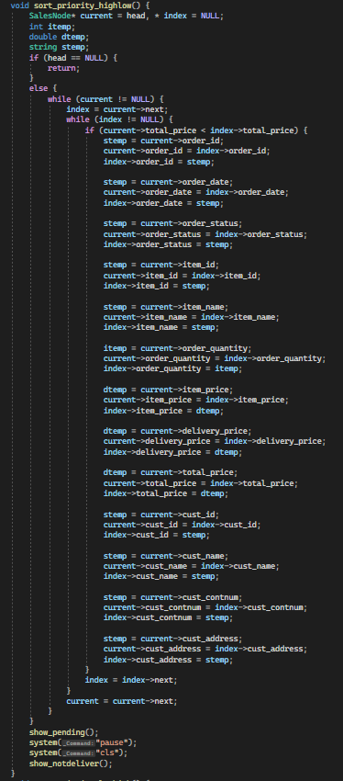

The first step to sorting data from highest to lowest priority is to ensure that the head is not empty (list cannot be empty). Maintain the current and index pointers if the head is not empty. Current will initially point to the head node and index will point to the node after current. By comparing the data from current and index, go through the list until current points to null. If the total_price of the current data is higher than that of the index, then the data should be swapped between the two. The whole order record is then shown in the order of highest to lowest priority using the view order list() method.

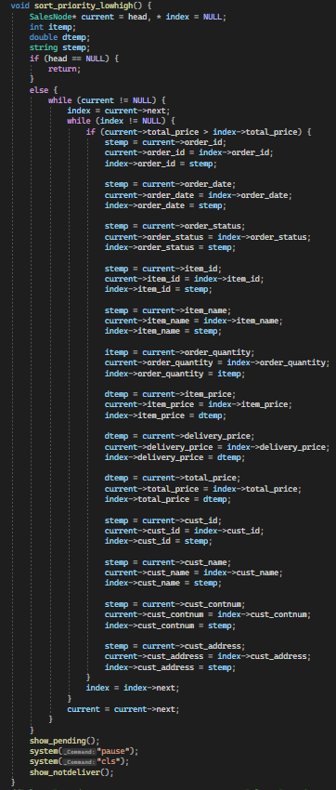Sort Records by Low to High Priority

The first step to sorting data from lowest to highest priority is to ensure that the head is not empty (list cannot be empty). Maintain the current and index pointers if the head is not empty. Current will initially point to the head node and index will point to the node after current. By comparing the data from current and index, go through the list until current points to null. If the total_price of the current data is higher than that of the index, then the data should be swapped between the two. The whole order record is then shown in the order of lowest to highest priority using the view order list() method.

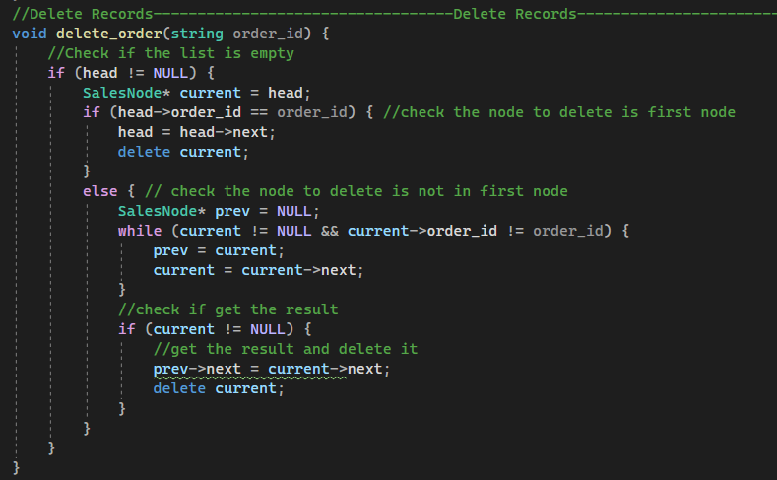Delete Records

To delete data in the linked list, the first thing is to verify whether the list is empty or not following by checking the first the head node over every occurrence. If the data that wanted to be deleted is in the first node, modify the head node accordingly to the next node. In addition, within a loop, the system must search for all occurrences and remove it one at a time if the data that is going to be deleted is not the first node.

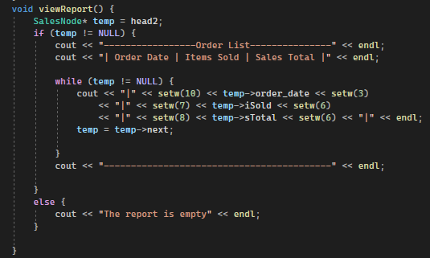View Reports

The pointer “temp” will be directed to the top of the node “SalesNode” and will be saved as the value of *head2.* If temp is not null, the system will display the order_date, iSold, and sTotal that are stored in the node “SalesNode”. The temp will then move to the next saved data and will repeat until there are no more data available to be displayed.

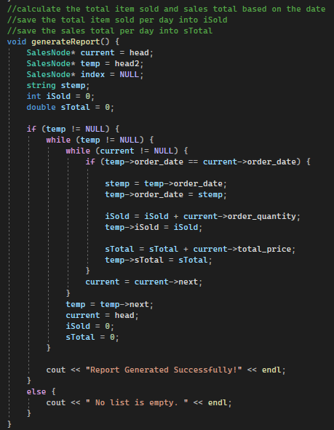Generate Reports

This function is accessible only to administrators and produces sales reports. To generate reports, the first thing is to create new variables from the nodes. Then, algorithms will begin to generate nodes based on the order_date, iSold, and sTotal properties. In order to create a report, the new node will insert order information such as the total number of items sold, and the total price from the sales record based on the date respectively. The successfully generated report will then be shown when using view_report() function.

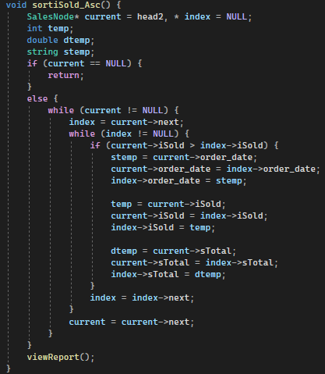Sort Reports by Ascending Items Sold

This function will sort reports based on the items sold in ascending order (least sold item to most sold item). The system will assign *head2* which is obtained from the node “SalesNode” to current and will check if *head2* is not empty. Current will initially point to the head node and index will point to the node after current. If current is empty the system will not perform any display, whereas if current is not empty, the system will then check if the value of current is greater than the index value. If the items sold (iSold) amount of current is greater than that of the index amount, then the data will be swapped between the two. The whole report is then shown in the order of lowest to highest total items sold using the viewReport() method.

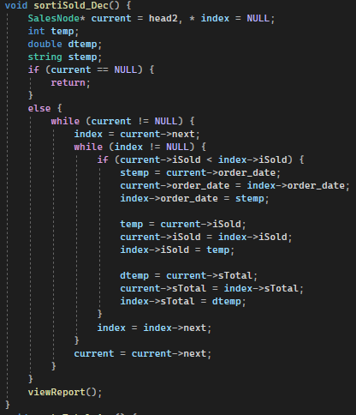Sort Reports by Descending Items Sold

This function will sort reports based on the items sold in descending order (most sold item to least sold item). The system will assign *head2* which is obtained from the node “SalesNode” to current and will check if *head2* is not empty. Current will initially point to the head node and index will point to the node after current. If current is empty the system will not perform any display, whereas if current is not empty, the system will then check if the value of current is lesser than the index value. If the items sold (iSold) amount of current is lesser than that of the index amount, then the data will be swapped between the two. The whole report is then shown in the order of highest to lowest total items sold using the viewReport() method.

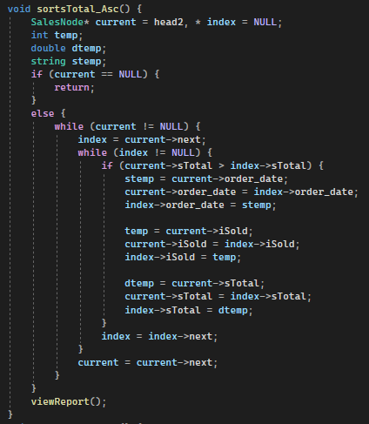Sort Reports by Ascending Sales Total

This function will sort reports based on the total sales in ascending order (lowest sales to highest sales). The system will assign *head2* which is obtained from the node “SalesNode” to current and will check if *head2* is not empty. Current will initially point to the head node and index will point to the node after current. If current is empty the system will not perform any display, whereas if current is not empty, the system will then check if the value of current is greater than the index value. If the total sales (sTotal) amount of current is greater than that of the index amount, then the data will be swapped between the two. The whole report is then shown in the order of lowest to highest total sales using the viewReport() method.

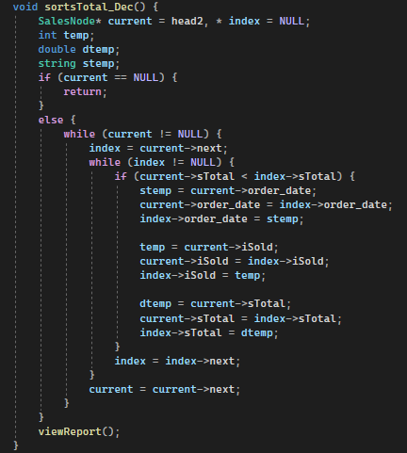Sort Reports by Descending Sales Total

This function will sort reports based on the total sales in ascending order (highest sales to lowest sales). The system will assign *head2* which is obtained from the node “SalesNode” to current and will check if *head2* is not empty. Current will initially point to the head node and index will point to the node after current. If current is empty the system will not perform any display, whereas if current is not empty, the system will then check if the value of current is lesser than the index value. If the total sales (sTotal) amount of current is lesser than that of the index amount, then the data will be swapped between the two. The whole report is then shown in the order of highest to lowest total sales using the viewReport() method.

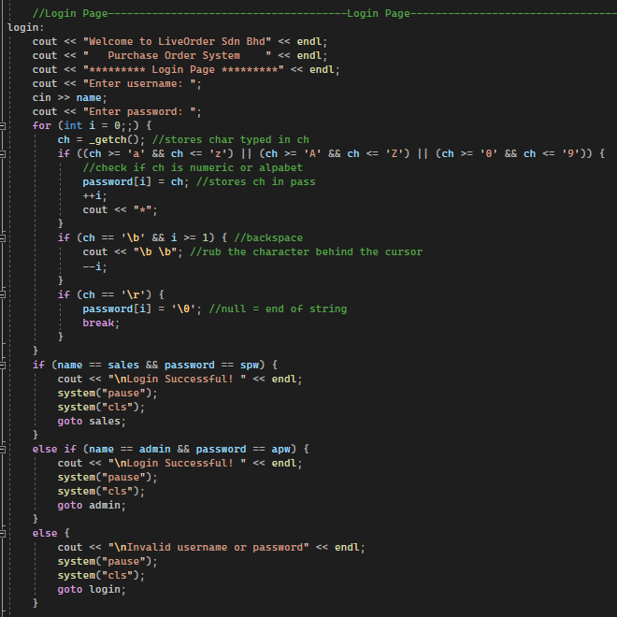Sales Order Executives and Admin Login

The login function is implemented for users (sales order executives and administrators) to access the system. The system will prompt users to input username and store the input into a variable called *name*. Then the system will ask user for password, and for every input the user provides, the system will first check if the input is a character from a to z, A to Z, or 0 to 9. Then, if the character is “true” it converts the said character to “*” and output it on the screen. The pre-saved username and password for sales role is “sales” and “sales” respectively, while for administrators is “admin” and “admin” respectively. When the correct input for username and password for either sales or admin roles have been entered, the user will be prompted that the login has been successful. On the other hand, if the input is wrong, user will be prompted to re-enter the username and password.

Sales Order Executives Logout

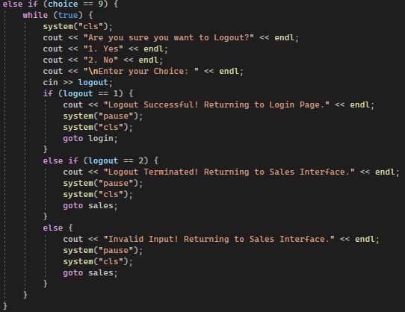

The logout function will allow users to return to the login page and will have to re-enter username and password to access the system again. Users will be given a confirmation on whether or not they want to logout and these options are “1” and “2”. Inputting “1” will successfully logout users and return them back to the login page, whereas inputting “2” or any other character will bring users back to the sales order executive’s menu (Sales Interface).

Administrator Logout

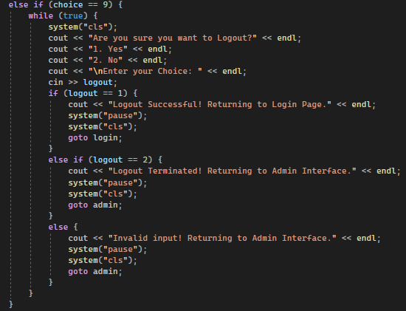

The logout function will allow users to return to the login page and will have to re-enter username and password to access the system again. Users will be given a confirmation on whether or not they want to logout and these options are “1” and “2”. Inputting “1” will successfully logout users and return them back to the login page, whereas inputting “2” or any other character will bring users back to the administrator’s menu (Admin Interface).

# Screenshots of Input and Output Samples

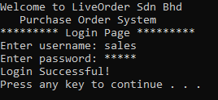Log In Screen

The system will prompt user to input username and password on the start-up screen. When login is successful, user will be able to proceed to sales/admin menu based on the credentials inputted.

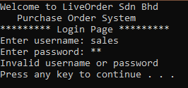

If there are incorrect username or password inputted, the system will not allow access and will notify user that there are wrong inputs during the login attempt. Users can then try to re-login again after pressing any key.

Sales Order Executive Menu

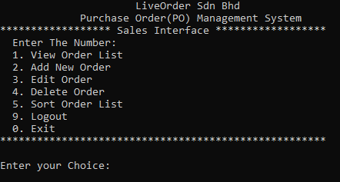

User will be prompt with a sales interface/menu once logged in as a sales order executive. The user can then choose which function they want by inputting the relative number of the function.

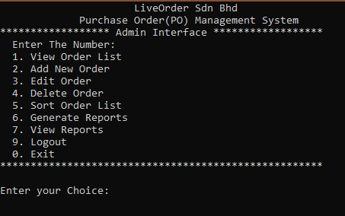Administrator Menu

When logged on as an administrator, the user will have access to two additional functions – generate report and view reports. As mentioned before, they can choose their preferred function by inputting the number associated with the function.

View Order List

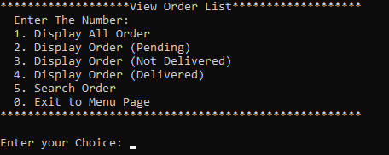

After selecting “1” in the menu, the user will be brought to the “View Order List” page, where they must then how they would like the order to be shown.

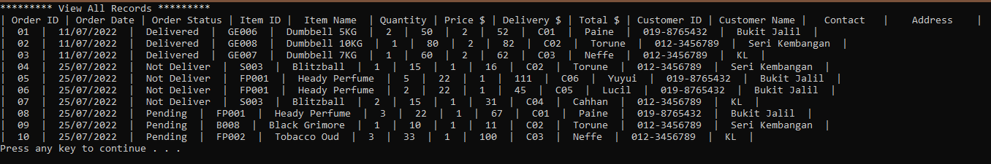Display All Orders

When choosing to display all orders (“1” is selected), the system will allow users to view all orders without any filters and will be brought back to main menu.

Display “Pending” Orders

By selecting option “2”, users can only view all pending orders and will be brought back to main menu.

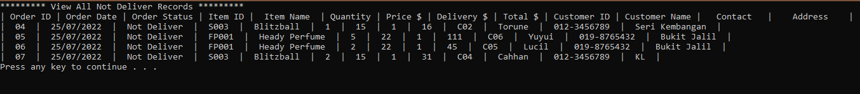Display “Not Deliver” Orders

When option “3” is selected, the user can display all not delivered orders and will be brought back to main menu.

Display “Delivered” Orders

The user can view all delivered orders when choosing option “4” and will be brought back to main menu.

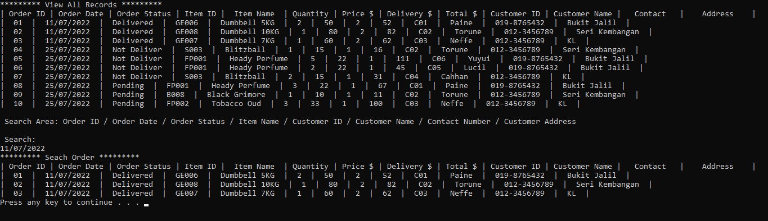Search Order

When option “5” is selected, user can search orders based on Order ID, Order Date, Order Status, Item Name, Customer ID, Customer Name, Contact Number, and Customer Address. In the example above, the user searched orders based on Order Date of 11/07/2022, and all orders on that day were displayed. Users will be brought back to main menu after viewing.

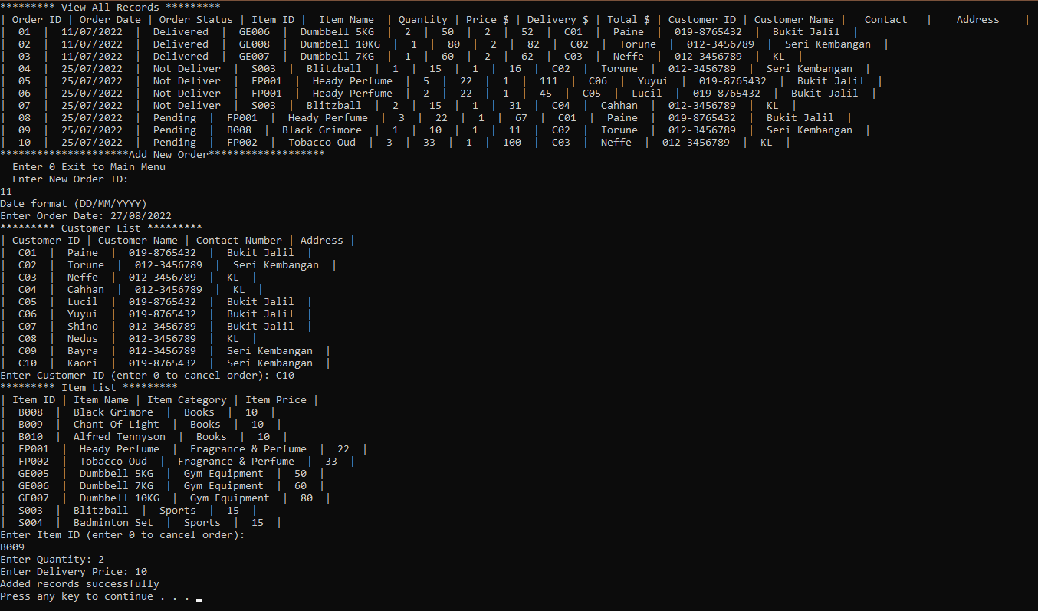Add New Order

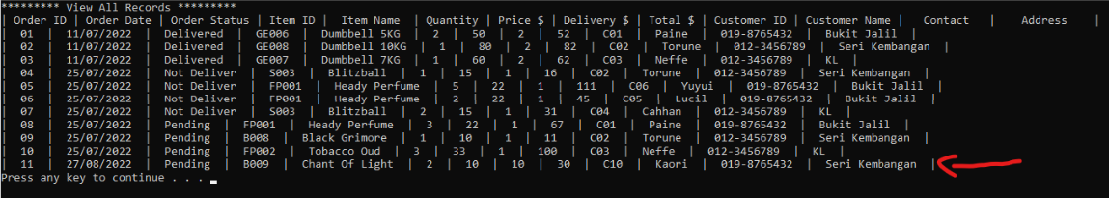The “Add New Order” function can be accessed by selecting “2” in the Sales Menu or Admin Menu. When chosen, users are prompted to key in information which will be included in the records. User must enter Order ID, Order Date, Customer ID, Item ID, Item Quantity, and Delivery Price. These details will then be stored into the records as shown below.

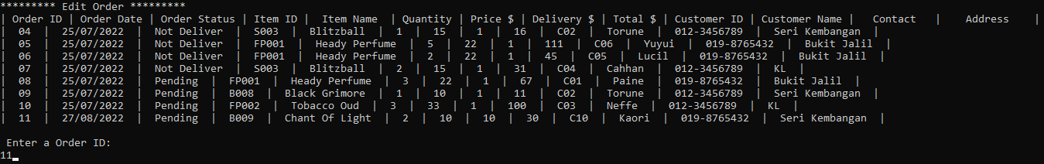Edit Order

Editing Order can be used by selecting option “3” in the menu. When selected, users are required to input the Order ID of the order that needs to be edited. In the example above, Order ID “11” was inputted and the results are shown below.

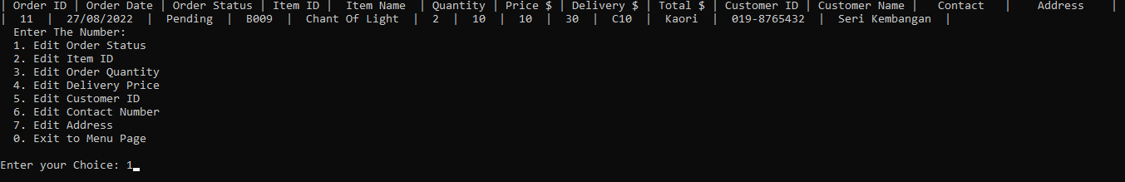As shown in the image above, only the Order ID of “11” will be displayed, and users can then decide what needs to be edited in that particular order. The example shows that the Order Status will be edited.

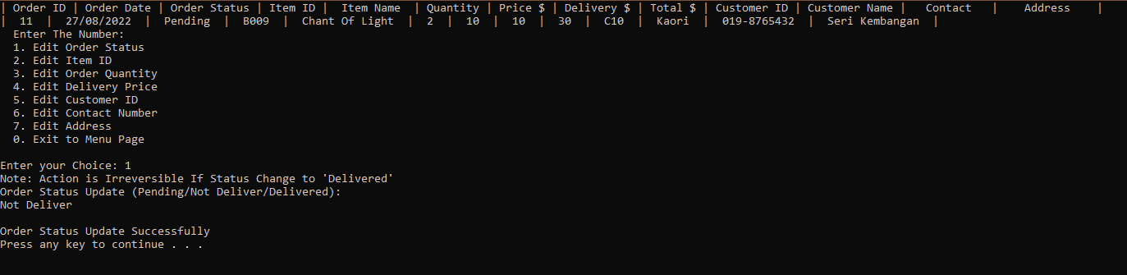After the Order Status has been inputted, users can press enter to save the details in the record.

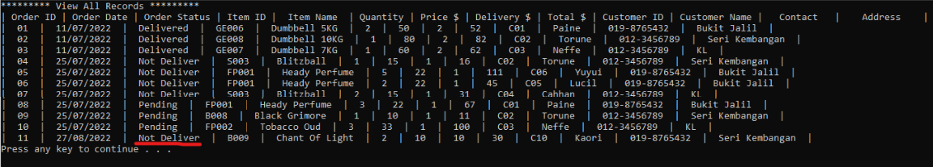The Order Status has been changed from “Pending” to “Not Deliver” successfully as shown above.

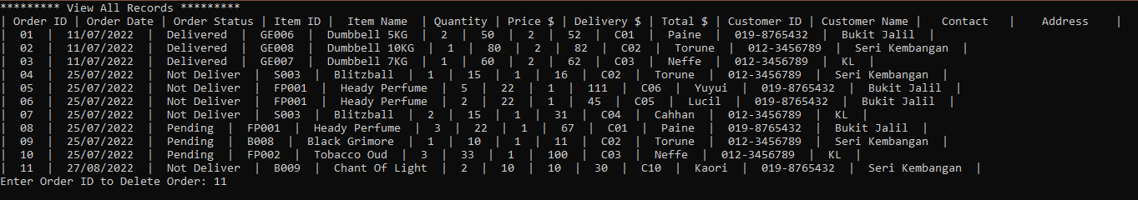Delete Order

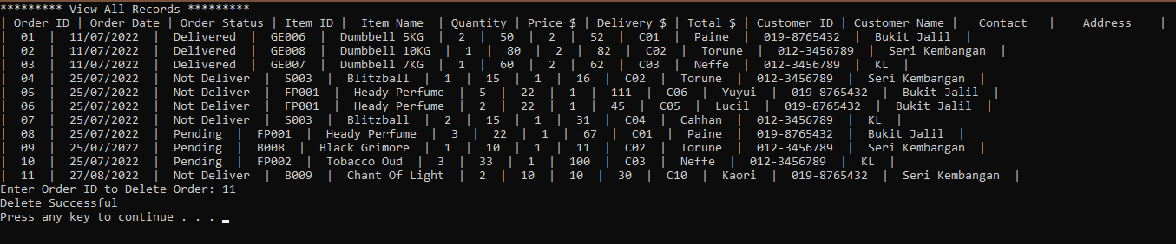User can delete orders by choosing “4” on the menu. User can input Order ID and the order will be deleted. In the given example, order with Order ID “11” will be deleted from the records.

User will be shown that the order has been deleted successfully after pressing enter.

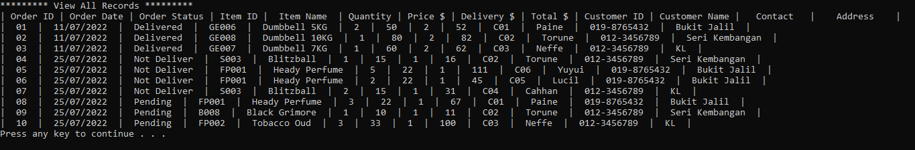The updated records will not contain the order with Order ID “11” as shown in the image above.

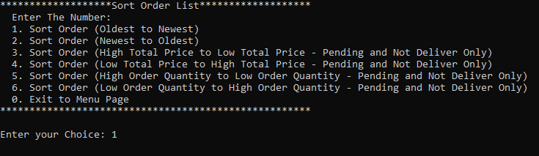Sort Order List

Users can sort order lists by selecting “5” in the menu page. There are six ways users can sort the orders, which are sorting orders from oldest to newest, newest to oldest, highest total price to lowest total price, lowest total price to highest total price, highest order quantity to lowest order quantity, and lowest order quantity to highest order quantity. The sample provided will sort order from oldest to newest.

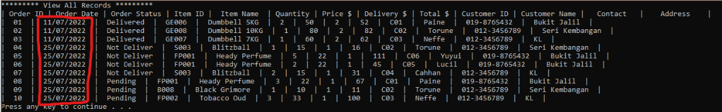As shown, the orders will then be sorted from the oldest to the newest orders based on the order date.

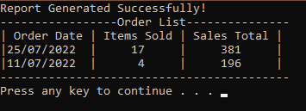Generate Reports (Administrators Only)

Administrators can only perform this function. It can be accessed by entering “6” in the Admin Interface, and the report will be automatically produced. It will display the order date, and the total items sold, and the total sales made on that day.

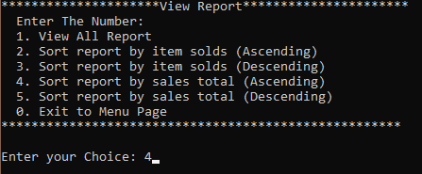View Reports (Administrators Only)

Administrators can view and sort reports by inputting “7” on the Admin Interface. The user will then be prompted with a menu that consists of the “View All Report” function, and four different sort functions based on the user’s preferred criteria. These criteria include sorting reports by item sold in ascending order, item sold in descending order, sales total in ascending order, and sales total in descending order. The example provided above selected option “4”, which is to sort report by sales total in descending order.

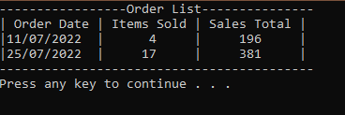

The system will then display the report and sort the elements based on the descending order of sales total.

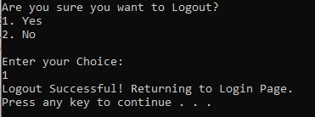Logout

Users can choose to Logout by selecting option “9” in Sales Interface and Admin Interface. The system then prompts the user to select between “1” or “2”. When “1” is selected, user will be brought back to the login page. On the other hand, when the user chooses “2”, they will be brought back to their respective menus. The example shows that the input is “1”, and the system will notify that user has successfully logout and will be returned to the login page.

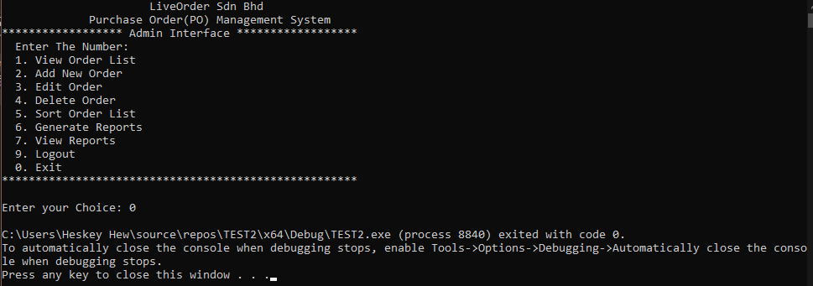Exit

User can exit the system completely by inputting “0”, and the system will be instantly terminated as shown in the image provided above.

# Conclusion

The purchase order management system has been developed for LiveOrder Sdn. Bhd. successfully. All functions and features that were required has been implemented within the system. The two roles – Sales Order Executives and Administrator roles have been modified in a way that both roles are able to perform and execute the functions to which they are limited. The system definitely has space for improvement, especially in the “Generate Report” function and the display of the purchase records and order records could be arranged in a tidier manner. The purchase order management system is able to complete the sorting feature based on pre-specified criteria, and the search function can search records based on user-inputted criteria. Overall, although the system has its limitations, it is still considered to be a viable system for LiveOrder Sdn. Bhd.

# References

GeeksForGeeks. (2022, June 18). *Searching Algorithms*. Retrieved from GeeksForGeeks: https://www.geeksforgeeks.org/searching-algorithms/?ref=lbp

GeeksForGeeks. (2022, June 18). *Sorting Algorithms*. Retrieved from GeeksForGeeks: https://www.geeksforgeeks.org/sorting-algorithms/?ref=lbp

javaTpoint. (n.d.). *Deletion in singly linked list at beginning*. Retrieved from javaTpoint: https://www.javatpoint.com/deletion-in-singly-linked-list-at-beginning

Programiz. (n.d.). *Insertion Sort Algorithm*. Retrieved from Programiz: https://www.programiz.com/dsa/insertion-sort#:~:text=Insertion%20sort%20is%20a%20sorting,we%20select%20an%20unsorted%20card.

Software Testing Help. (2022, June 13). *Linked List Data Structure In C++ With Illustration*. Retrieved from Software Testing Help: https://www.softwaretestinghelp.com/linked-list/#1_Insertion

tutorialspoint. (n.d.). *Data Structure and Algorithms - Linked List*. Retrieved from Tutorialspoint: https://www.tutorialspoint.com/data_structures_algorithms/linked_list_algorithms.htm

# Workload Matrix

|  |  |  |
| --- | --- | --- |
| **Task**  **Assigned** | **Heskey Hew U Cern (TP058243)** | **Lee Jun Lam**  **(TP055697)** |
| *Obtain Purchase Records* | *50%* | *50%* |
| *Modify/Update Order* | *50%* | *50%* |
| *Display/View All Orders* | *50%* | *50%* |
| *Sort Purchase Orders* | *50%* | *50%* |
| *Search Purchase Orders* | *50%* | *50%* |
| *Generate Reports* | *50%* | *50%* |
| *Sort Reports* | *50%* | *50%* |
| *Login/Logout* | *50%* | *50%* |
| *Documentation* | *50%* | *50%* |
| ***Signature*** | Heskey | Jun Lam |

# Source Code of Main Function

